**GUI AND DISPALYING RESULTS OVERVIEW**

* *Main highlights of the process have been migrated to Spyder and a small GUI has been built.*
* *Not all process has been implemented in the GUI and as some of the other main process remain in the backend only.*
* *This GUI is only for displaying an overview of the Main flow and results. Entire code is available in Jupyter.*

**Code File:** *NewGUI*

1. Run the python file *NewGUI* in Spyder. This is the front screen of the GUI initially.

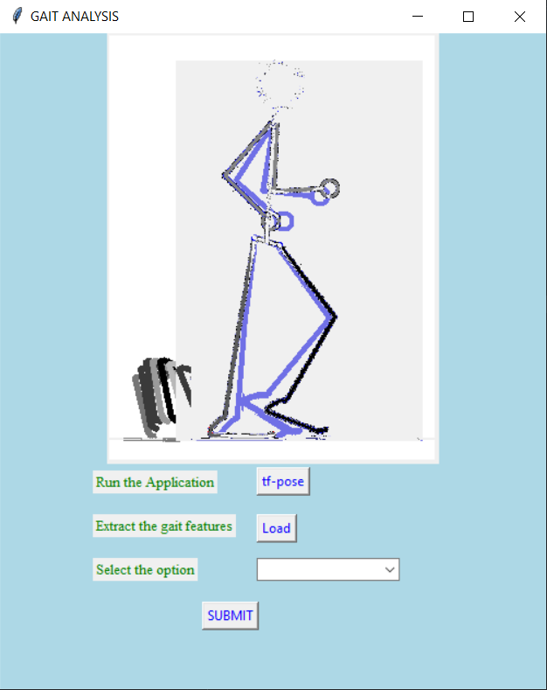

1. In the **“Select the option”** drop down, you can choose which experiment you want to conduct.

*Eg: Normal, Counting Backwards 3 (CB3), Counting Backwards 7 (CB7) etc. has already a trained model.*

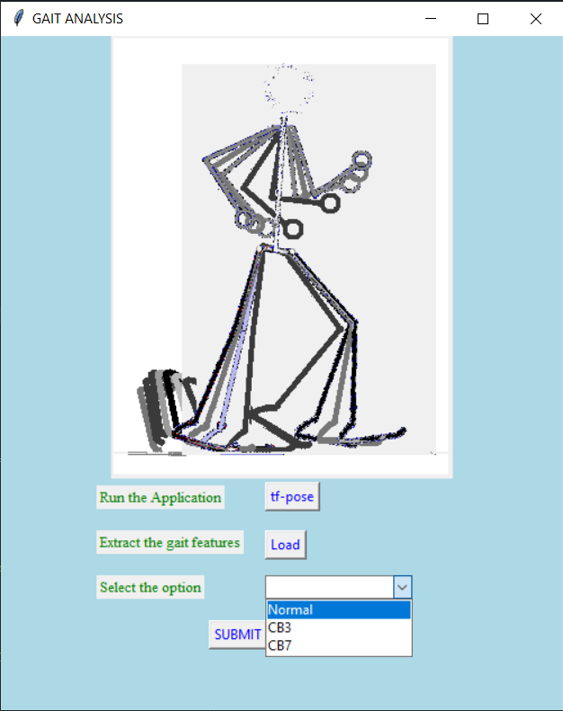

1. Click on **Run the application**🡪 **“tf-pose”** button to launch the command window.
2. Navigate to the project directory and run the python file.

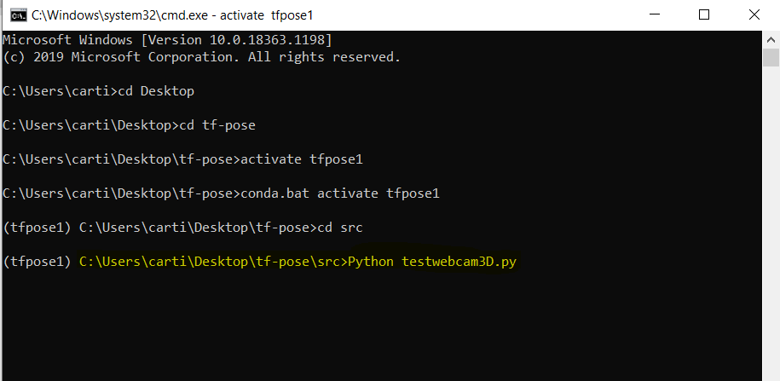

1. Now a person will walk Infront of the camera, the stick figure will appear and frames start to capture. Time limit of 10 secs has been noted and then window is closed manually.

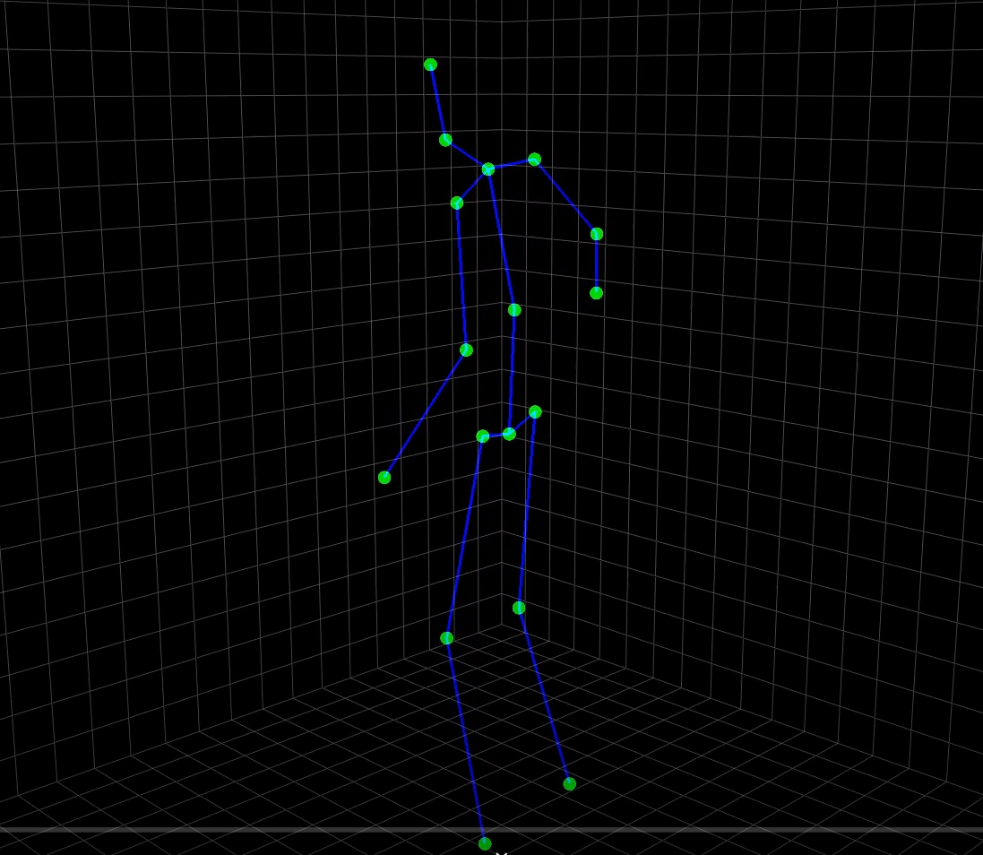

1. The captured values will automatically be loaded to a file *pose_3d* in a directory from which we can process them. Then click on the button **Extract the gait features** 🡪 **“Load”** to extract the necessary features from the file for further processing. (Complete automation of calculation of features and other parameters necessary are done in the backend.)

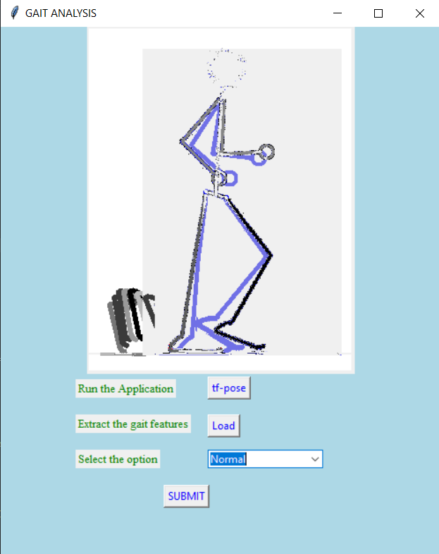

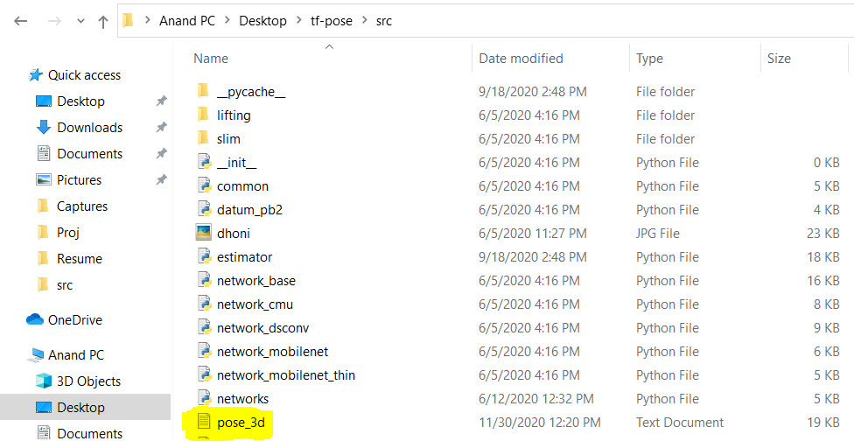

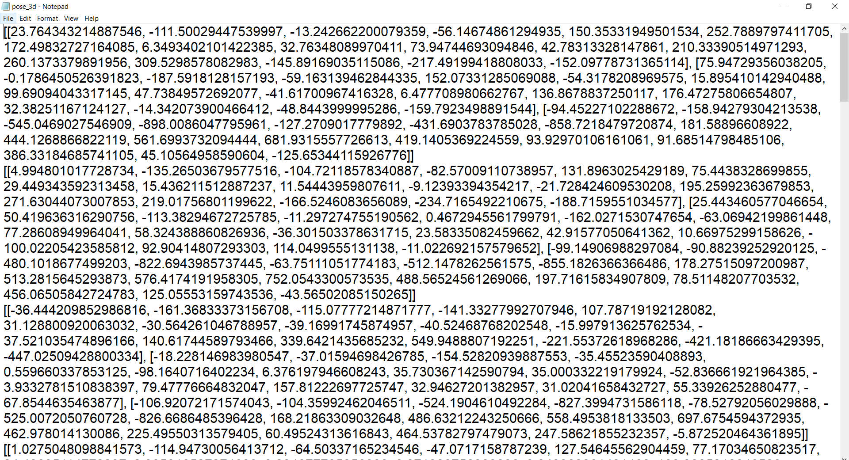

1. Then click on the **“Submit”** button to get the results displayed on the console window of Spyder.

The console will display the following:

1. **Gait parameters:** *Step length, Step width, Gait speed*
2. **The class of the persons**: *1- Normal, 0- MCI*
3. **Accuracy:** *The test records will be evaluated with the trained model (: Normal, Counting Backwards 3 (CB3), Counting Backwards 7 (CB7) etc.) using the algorithm below.*
4. Logistic regression
5. Naive Bayes

